Beyond the Pie:

Communicating with Smart Objects using

Menu-based Natural Language Interfaces
Tanmaya Kumar <tkumar@uark.edu>, Craig Thompson <cwt@uark.edu>
Computer Science and Computer Engineering Dept., University of Arkansas, Fayetteville ARALAR Full Paper

Beyond the Pie:

Communicating with Smart Objects using

Menu-based Natural Language Interfaces

Abstract
To extend the 3D virtual world Second Life to better model pervasive computing, this paper shows how to build a dynamic menu-based user interface that enables humans to communicate with model entities.

1. Context
This report is associated with the Everything is Alive project at the University of Arkansas that is exploring pervasive computing both in real-world RFID applications [1] and using virtual worlds, esp. Second Life [2] and OpenSim.

2. Problem
People use natural languages to talk to other people. Researchers have been trying to develop natural language interfaces (NLIs) to talk to e.g., databases for the past 40 years but with limited success. It is currently difficult-to-impossible for people to communicate and converse using NLI with (most) non-human things around them (chairs, thermostats, pets, blood pressure machines, fork lifts, …). A recognized reason is the habitability problem [1]: humans overshoot and also undershoot a system’s ability to understand their language. Overshooting means people use language that the system fails to comprehend, so the system is unable to respond to the command appropriately. Undershooting means people fail to realize the capabilities of the system and therefore refrain from using many powerful features of the system. Another major issue with objects around us is that they do not explicitly know their own identity or type – I am a unique chair, nor do they have a way to associate additional information with themselves – I am owned by Tanmaya … I am a light switch that has been turned on 313 times this year.
Its not just real world objects we want a way to talk to. In virtual worlds, in-world objects may have associated information and scripts but the ability to know information is available or how an object can be manipulated may rest in the head of the object developer. No avatar passing by can learn the command language of the object. To aid the user Second Life does offer the PIE user interface that can be accessed by a user by selecting an object and which allows the user to access generic commands such as sit, take, copy, buy etc. However none of these commands are object specific and do not allow the user to manipulate the special capabilities the object may have, for example thermostats do not have their own object type specific commands.

3. Approach
Form Based Graphical User Interfaces (GUI’s) provide a common way humans communicate with computer-based objects. A complementary alternative is Menu Based Natural Language Interfaces (MBNLI’S), which provide sequential command completion menus [3]. Both provide a way to solve the habitability problem since both provide a way to display all and only the legal commands a system can handle. Instead of “creating” a query without support as done in conventional NLI, using GUI or MBNLI, human users can “recognize” the command they meant to formulate while creating an appropriate string of commands using a command builder. This method also enables humans to see commands that they might not have known about – that is, humans are guided to rendezvous with the capabilities of the system, thus eliminating the chance of a user undershooting or overshooting a system’s capabilities.

4. Objective
Our objective is to develop a way for humans to communicate with things – both real world things and virtual world things.

5. Related work
This paper described a prototype next-generation dynamic PIE user interface that humans can use to communicate with things – see [4] for a more detailed tech report describing this work. Companion papers describe:
- protocols for extending an ordinary real or virtual world object into a smart object [5]
- a universal soft controller architecture that humans can use to communicate with things [6]
- an ontology service that associates knowledge and interfaces with things [7]

6. Progress
We developed a prototype next generation PIE interface for Second Life that uses a combination MBNLI-GUI to enable humans to communicate with specific things.
In our initial implementation, we limited interactions to one type of entity – robots [8]. A student at University of Arkansas, Nick Farrer, had previously developed a Robot Assembly Language that provided chat-based commands in Second Life for controlling a fleet of robots. Robots can go from location to location following way points. They can pick up, carry, and put down objects.
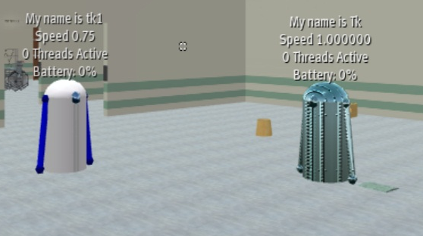
Fig. 1: Robots in SL controlled by a Robot Command Language
In order to get a PIE that operated in both Second Life and OpenSim, we developed our PIE code outside both environments so that it overlays as an external application on top of those browser-clients.
We developed object-specific grammars like the one shown below for robots. If the user clicks on a robot, the grammar commands for the robot are interpreted and displayed in a cascade on the menu. At the end of a PIE command sequence like “Robot – Pickup – the ball”, the command is translated into a command in the Robot Command Language and then executed.
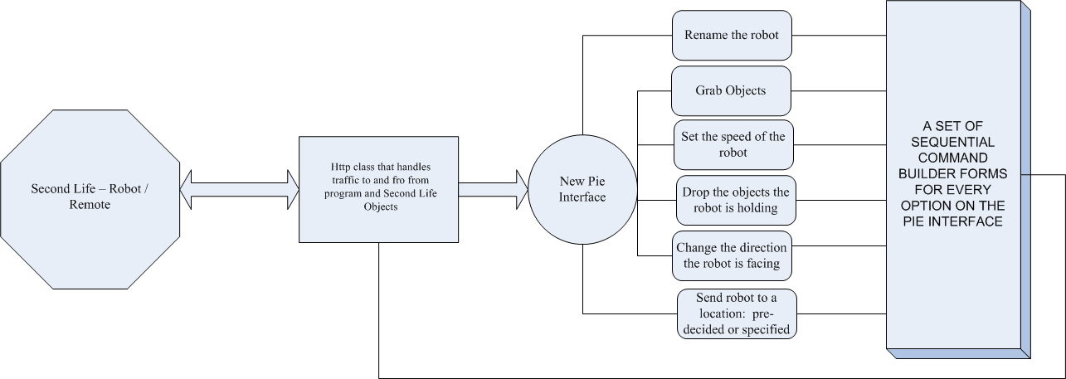
Fig. 2: The program design and interaction paradigm
The dynamic PIE is show below:
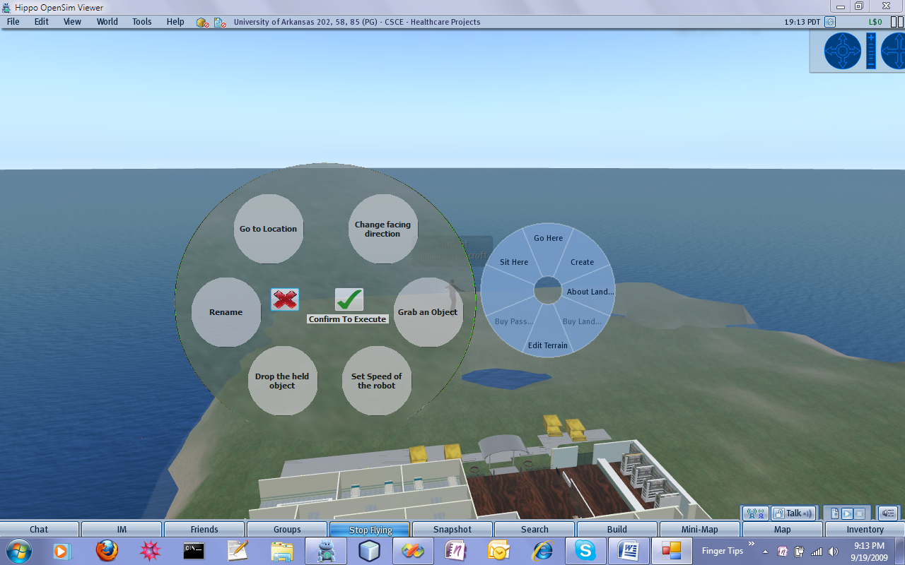
Fig. 3: The new pie interface (left) [2] vs. the one provided by Second Life (right)

6. More work needed
While the research we conducted allowed us to understand the working of the Second Life PIE in detail, it was a prototype hardcoded to control the Robots on “University of Arkansas” island in Second Life. Even then, the interface did not cover all of that command language. Most other Second Life objects still lack the ability to understand their own type and super and sub classes; which might be another place to begin. The grammars are not yet dynamically loaded into the PIE. So there is considerable work ahead – but we have isolated a next set of problems to solve.

7. Potential Impact
If we can determine the kinds of interfaces an object can possess and then develop a synthetic grammar for the commands and replies for the object and then extend the communication interface to support such interaction, it will make it possible for humans to interact with objects. We believe that a similar approach can be used for people using soft controllers (smart phones) to communicate with everyday objects in the real world. Consider if every real world object has an RFID tag that indicates the object’s individual ID. A smart phone with and RFID reader could communicate this information to a remote ontology on the web to download an interface that lets a consumer talk to the thing. If it becomes a standard (optional) protocol to define such interfaces for all things, then anyone anywhere can communicate with any tagged thing!

8. Notes
We believe
- Smart objects could have GUI, MBNLI interfaces, command line interfaces, or other kinds of interfaces.
- Smart objects may have multiple interfaces – so some people might want access to all commands for their object but commands could be turned off for security or complexity reasons.
- Interfaces could be arranged into a type-subtype hierarchy with interface inheritance to make it easier to build interfaces (grammar reuse).
- The same interface and grammar set could command different objects from the class type – the same thermostat interface could be used to command thermostats from different manufacturers.
- Commands command not just individual things but collections and assemblies of things as well as rules for associating things
We also believe it would not he hard to add speaker dependent speech so a person could read the menus.

References
[1] Everything is Alive project website (aka Modeling Healthcare in a Virtual World), http://vw.ddns.uark.edu
[2] Second Life website, http://www.secondlife.com
[3] C. Thompson, P. Pazandak, H. Tennant, “Talk to your Semantic Web,” IEEE Internet Computing, November-December 2005.
[4] Tanmaya Kumar, "Enabling Communication between Humans and Inanimate Objects in a Virtual World," Final Report, Undergraduate Research Project, Honors College, University of Arkansas, Fall 2009.
[5] A. Eguchi, C. Thompson, "Smart Objects in a Virtual World," X10 Workshop on Extensible Virtual Worlds, venue: Second Life, March 29 – April 2, 2010
[6] J. McCrary, C. Thompson, "Soft Controller – A Universal Remote for the Internet of Things and for Virtual Worlds," X10 Workshop on Extensible Virtual Worlds, venue: Second Life, March 29 – April 2, 2010
[7] T. Censullo, C. Thompson, "Semantic World: Ontologies in the Real and Virtual World," X10 Workshop on Extensible Virtual Worlds, venue: Second Life, March 29 – April 2, 2010
[8] Nick Farrer, "Second Life Robot Command Language," Tech Report, CSCE Department, University of Arkansas, Fayetteville, AR, 22 February 2009.

